Olympic Weightlifting  
Competition Management System

v2.8.2

Competition Setup Guide

Jean-François Lamy

lamyjeanfrancois@gmail.com

# About this guide

This guide describes how to prepare for running an Olympic Weightlifting Competition using the computerized Competition Management System. This guide is aimed at the competition secretary and covers setting up the software so that athletes are properly registered and allocated to competition sessions, and so on.

# Prerequisites

* At least one laptop is required to run the system.
  + Any reasonably recent laptop running Windows XP or more recent will do. The laptop should have more than 1GB of RAM, and any dual core laptop from 2006 onwards should do (1.4GHz or above clock speed is plenty).
  + You must have Administrator rights on the computer. This is normally the case for a personal laptop.
* You may access the application from the same laptop that is running the system
* For larger competitions, you will use additional laptops so you can attach projectors, computer screens, or flat-screen TVs to display the results, attempt screens, lifter displays, and so on. Other officials such as the timekeeper or marshall may also use additional laptops.
* Even though the system should work in any modern browser (Internet Explorer 8, Firefox, Chrome, Safari, WebKit) under Windows, Linux, Android and iOS, the most tested variation is Chrome under Windows.

# Initial Setup

The purpose of this step is to define the competition so the displays and competition documents make sense. We also need to define how many sessions will take place, and what they will be name. For youth competitions, we need to adjust the categories. Finally, if multiple competition platforms are needed due to simultaneous sessions, they need to be defined.

## Start and Access the System

* Start the system using the “Start Competition Management System” shortcut found on the desktop. You should see a black icon appear in the task bar at the bottom of the screen.  
  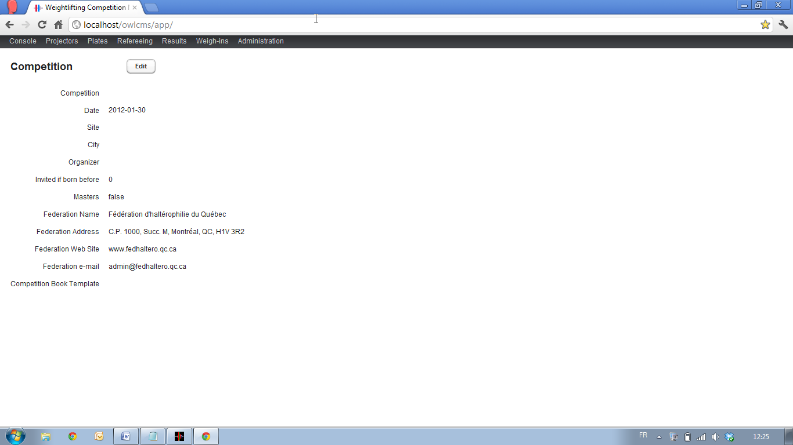
* Start the application using the “Competition App” shortcut found on the desktop. You should see a screen like this  
  

### Things to know

* The program operates with a database. Every time you change a value, the change is immediately performed in the database. There is no need to save anything. Everything is always saved. You can pull the plug at any time, or stop the application, and when you restart you will be exactly where you were.
* The program is accessed through a browser. The URLs (the complicated addresses shown at the top) are actually updated, so that if connections ever break (say because someone kicks the wireless router), when the system is made available again you can just refresh the page and in all likelihood, you will be exactly where you left.

## Getting Ready

### Remove Lifter Data From Previous Competitions

Typically, within a club or federation, much data remains the same between one competition to the next, so normally you only want to remove the actual lifting data from the previous meet.

To do so:

* Locate the “Administration” entry in the top menu bar, and select “Registrations”.  
  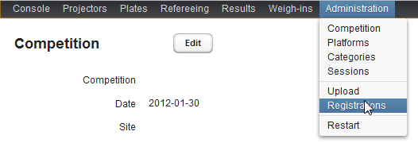
* In the screen that appears, click the “Delete these lifters” button as outlined below. Make sure that no session is selected (the drop-down next to the words “Current Session” is blank). If not, select the blank entry. This will clear the list.  
  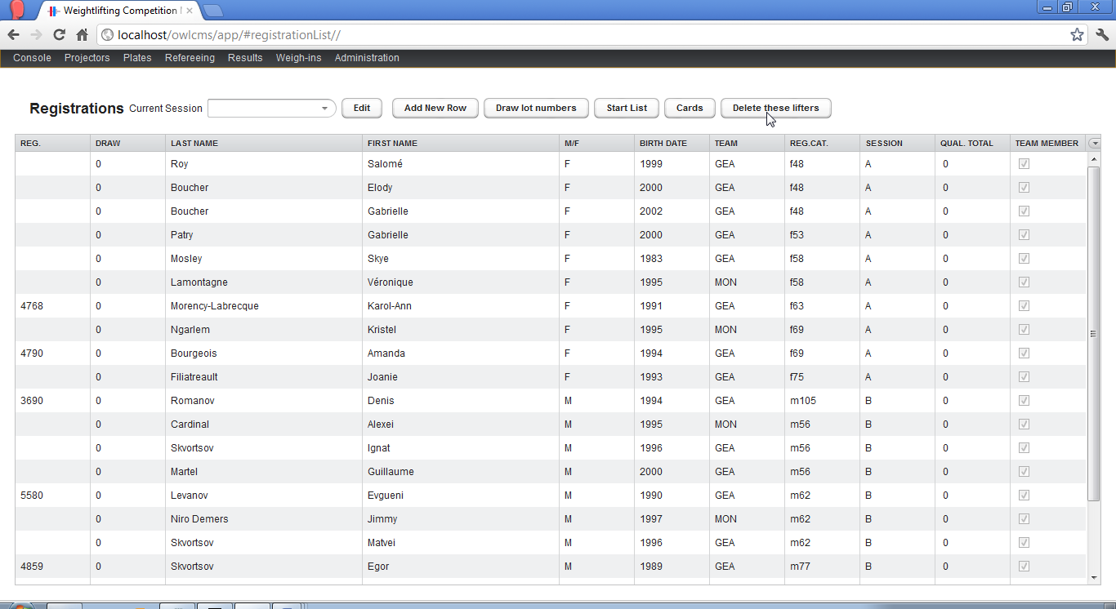

### Adjust the Categories for a Youth Competition

If you are running a standard IWF competition you may skip this step. If running a Youth competition, you need to adjust the categories prior to processing registrations. Please refer to section 5 for additional details.

In fact, this tutorial actually uses data from a Youth competition. However, we intentionally skip the adjustment so we can demonstrate how to fix mistakes after the fact.

## Update the Competition Sessions

Competition sessions are given a short name (often a letter or a letter and a digit), so that they can be referred to in competition documents. In order to assign athletes to sessions, creating the list of sessions is one of the first things that needs to be done.

* Under the “Administration” menu, select the “Sessions” item.
* In the Sessions screen, select the “Edit” button.

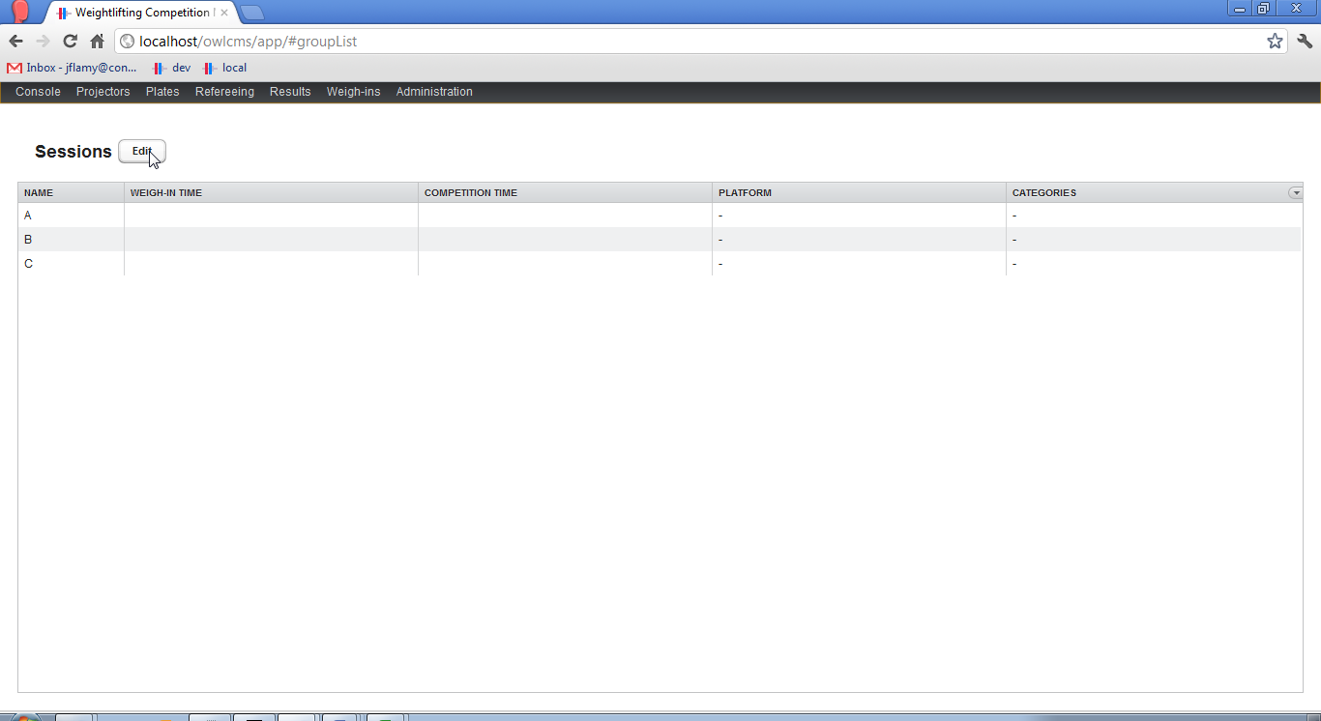

* The screen switches to an editable mode where you can click in the cells to change the values, and add additional sessions. In the following example, we have added an extra session “D” by clicking on the “Add New Row” button and editing the new row.

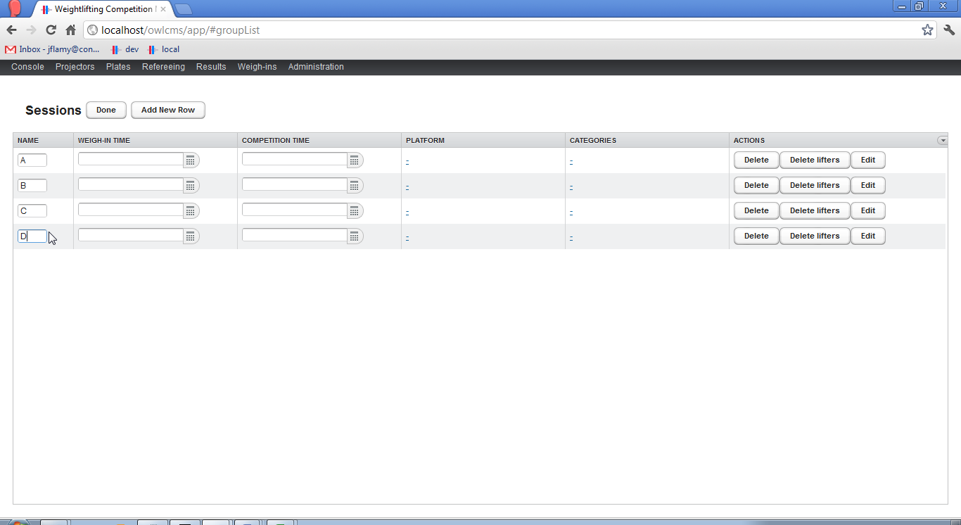

* Click the “Done” button where you are done editing.

## Athlete Registration

The simplest way to enter the athletes and assign them to sessions is to use the Excel template provided under the “Documentation” entry found in the “Competition Management System” program group. Any information entered by using the Excel template can later be edited through the web application.

### Locate the Registration Template

The simplest way to get started is to use the Excel template provided under the “Documentation” entry found in the “Competition Management System” program group.

* **Locate All Programs**: At the bottom left of the screen, locate the entry for “All Programs” that appears when clicking on the Windows menu (as highlighted below – the link will obviously be in your whatever language you run Windows under…)  
  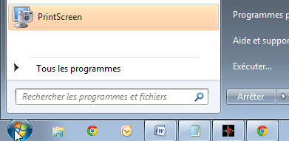
* **Locate the “Competition Management System” Program Group:** Click on the “All Programs” entry as shown in the previous item, and scroll down until you see “Competition Management System”. Clicking will show the various entries in the group, as follows 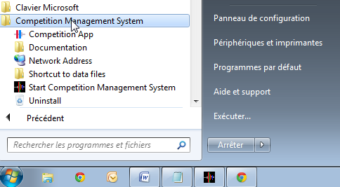
* **Open the template:** Click on the Documentation entry, and select **Registration Template.xls**

### Update Administrative Information

* The system can import information from a spreadsheet. It will read the header from the registration sheet and store the information. You may later edit it in the web application to change it as needed.
* Open the Excel file and change the information in the top part of the sheet to suit your needs. You may change formatting, but *do not* merge cells, add cells, add rows or add columns. For example  
  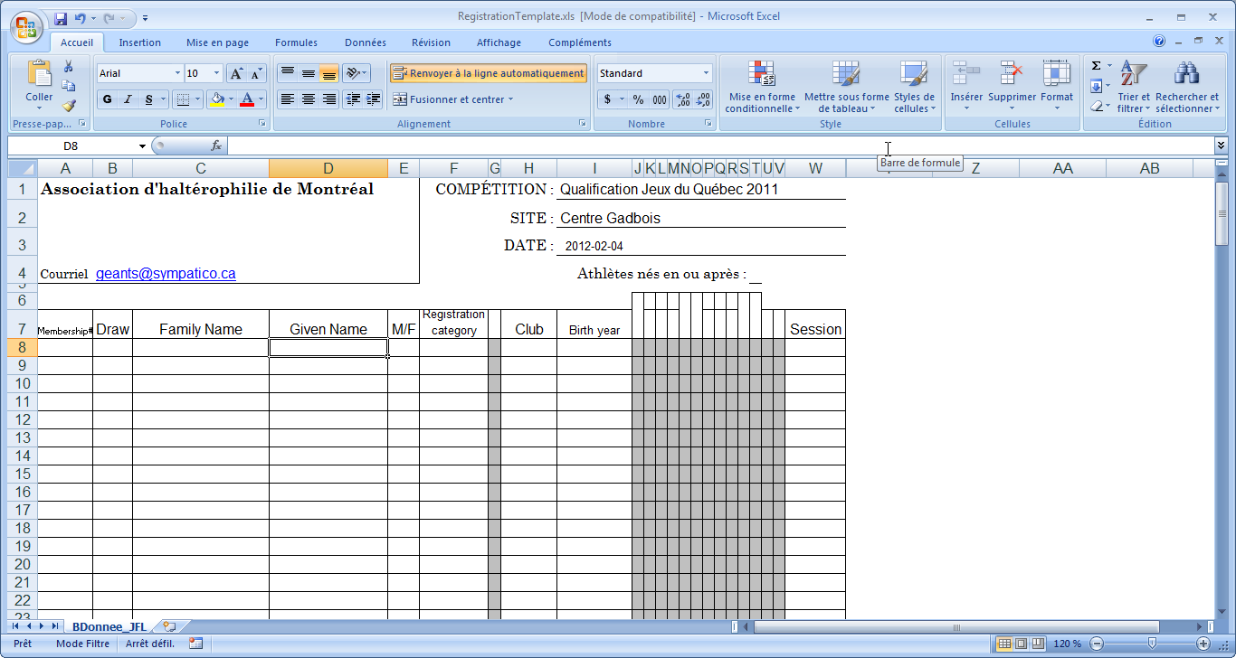
* Note that this file is only used as input – any change you make here does not affect the formatting of the competition documents.
* The date format is set according to the Year-Month-Day international ISO 8601 standard (that is,  
   2013-01-02 is January 2nd 2010)

### Enter Athlete Data

* Enter information about each athlete. Do not enter information in the greyed-out columns. Note the following
  + The membership column is optional. You may use it to type the four-character string  
     inv.   
    to denote an invited lifter that won’t be ranked officially. Normally it is used to record a Federation membership number to facilitate keeping statistics.
  + The draw number column is not used, normally, because the system is able to perform the draw. It is only used when a federation has a separate legacy system for handling registrations and printing lifter cards, which has already handled the draw.
  + The birth column is currently used for the Year-of-birth only. 4 digits are expected.
  + The category column is used for the declared registration category. For club meets or regional meets, you may choose not to use it – the program will simply assign the category based on the weigh-in.

The Registration Category string, if used, must match the list that appears in the “Administration” – “Categories” screen. Beware that “over 105 men” is written as m>105 and “over 75 women” is written as f>75.

* A sample spreadsheet for a club meet is shown below (all athletes are assigned to the same group)  
  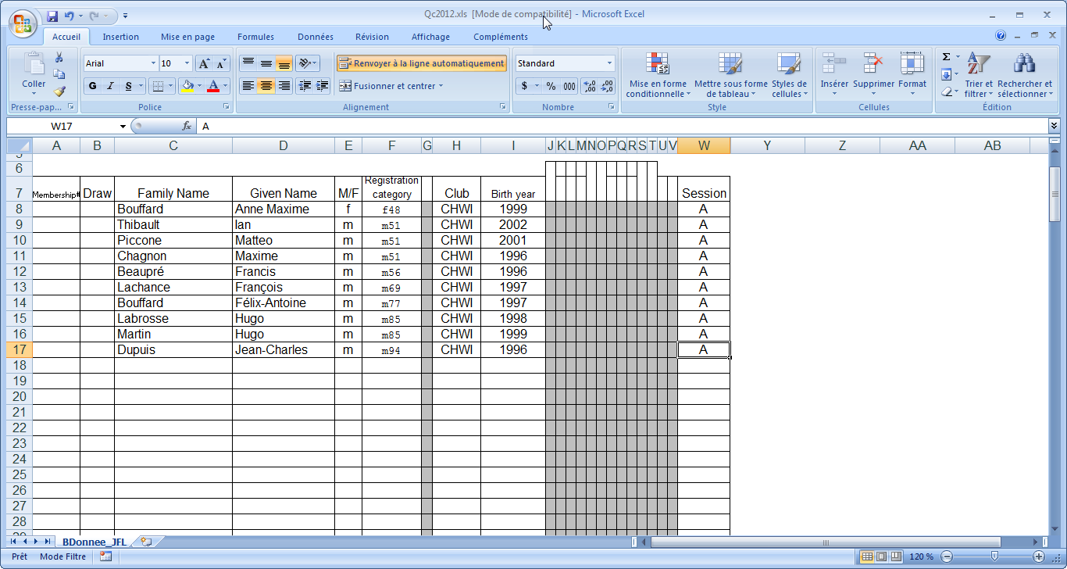
* Save the file on your disk, in a location you will remember, such as “Documents” or “Desktop”.   
  NOTE: You must use the Excel 97-2003 format for the registration file.

### Load the Registration Spreadsheet

* Under the “Administration” menu, select the “Upload” entry  
  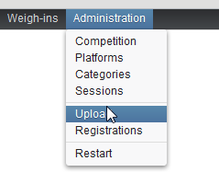
* This will bring you to the upload screen. Click on the “Upload a Registration File” as shown below and select the registration file you saved earlier.  
  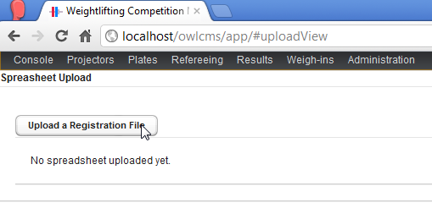
* Go to the “Administration” – “Competition” screen and observe that the information has been updated
* Go to “Administration” – “Registration” screen and check that all is correct. In this example, notice that three lifters do not have a registration category. This is because the lighter category for young men was not enabled, so when reading the spreadsheet the system did not find a match. We will show how to fix this in sections 5 and 6.  
  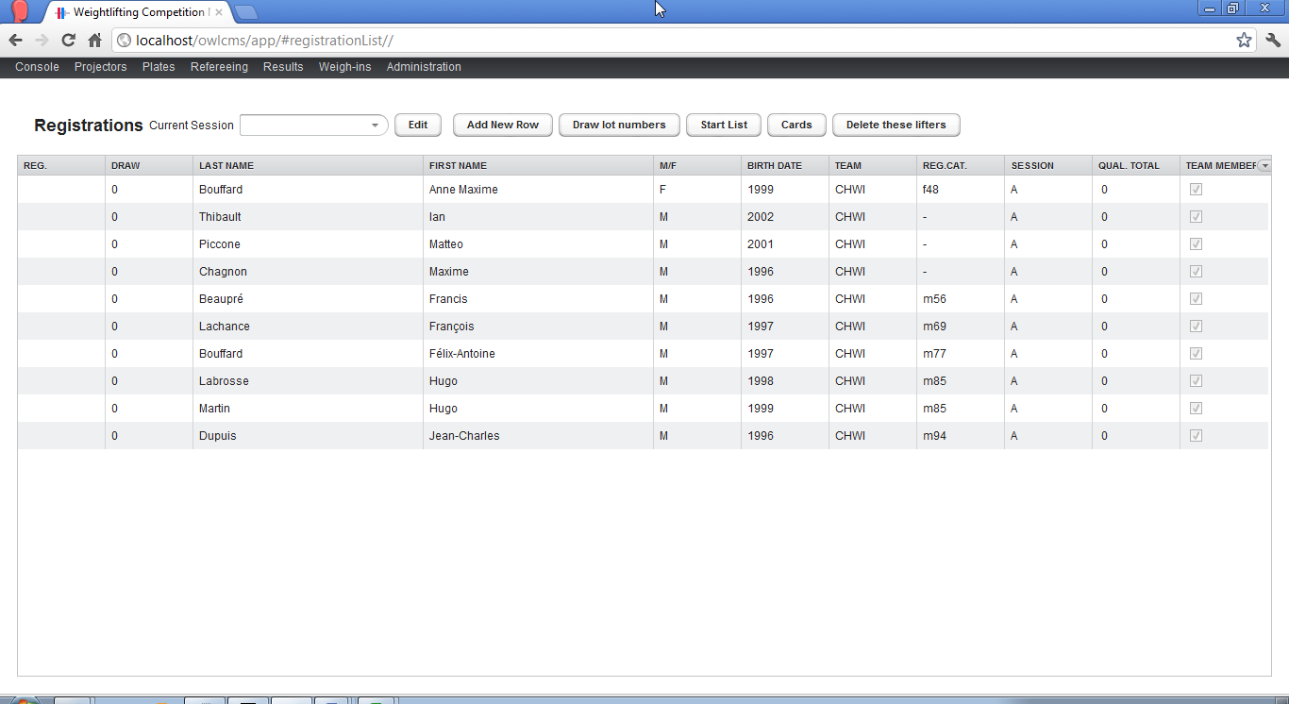

# Edit Competition Information

* Use the “Administration” – “Competition” menu item to reach the Competition Page
* Use the “Edit” button to change information as required.
* In the drop-down at the bottom of the page, select the “Standard” template.   
  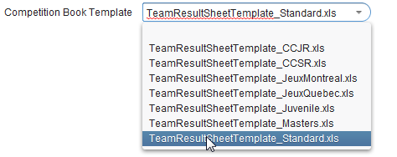

# Adjust Categories for Youth Championships

Normally this step is not required – by default the system uses the official IWF categories. You will also need to check this when reusing the same database after a youth championship.

* Use the “Administration” – “Categories” menu to reach the Categories screen.
* Use the “Edit” button to change categories
* Make sure that the proper categories are active.
* As an example, we will change male categories for a Youth championship. This means:
  1. Make the categories for small men active. Under IWF rules, this would be the m50 category. You will notice that the program has an m51 category instead (for historical reasons).
  2. Adjust the m51 category. Rename it to m50. Change the boundaries to start at 0.0 and end at 50.0 (the program is smart enough to know that the upper bound is included).
  3. Make the m50 category active. (click on the “Active” checkbox)
  4. Adjust the m56 category to start at 50.0.
  5. Disable the m105 and m>105 categories.
  6. Enable instead the m>94 category. Double-check that the maximum is 999.0. The special “and over” categories for youths are at the bottom of the list.
* **Perform a systematic check**
  1. Check that all used categories are active
  2. Check that all unused categories are inactive
  3. Check that all the active categories are correctly defined, starting at 0.0 for the smallest one, and ending at 999.0 for the largest one.
     1. Check that there are no weight gaps between active categories
     2. Check that there are no overlaps between active categories
* **RESTART THE SYSTEM**: After changing categories, the system must be stopped and restarted (they are read once, when the system starts).

The following screen shots demonstrate how we would correct the categories to accept the spreadsheet shown in section 3.4.3.

* We adjusted the m51 and m56 categories: they do not overlap, and there is no gap. Both are active. The spreadsheet used an m51 category instead of m50 – the program does not care, as long as the data is consistent.
* We adjusted the m>94 category and disabled the usual 105 and over 105 categories. The sequence m85, m94 and m>94 has no gaps or overlaps. You can see that m105 and m>105 are unchecked and therefore inactive.  
  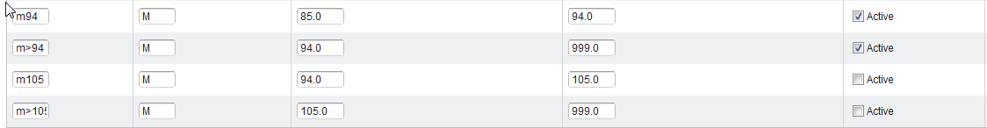

# Adjust Registration Data

* Access registration data using the “Administration” – “Registrations” menu
* Use the “Edit” button to make the entries editable.
* You may click on any cell to change the information (such as the Name, Club, etc.)
* In order to change the Registration Category, or the assigned Competition Session, For example, the following illustrates how to fix the category for a competitor
  + Click on the link for the category (a “-“ is shown if there is no assigned registration category)
  + A list shows up. You may scroll up or down in the list. Select the desired value
  + Move the mouse away, the selected value will be recorded.

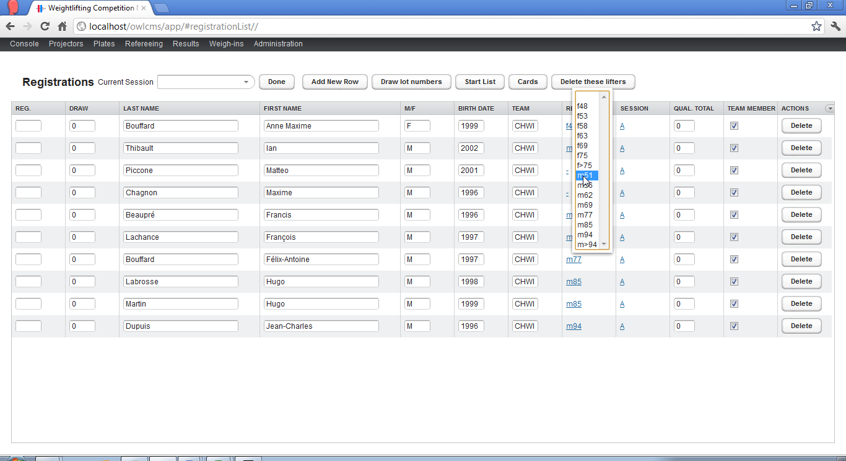

# Draw, Start List and Competitor Cards

* Go to the “Administration” – “Registrations” screen. There are three buttons on the menu bar for each of the following functions
  1. The “Draw lot numbers” button will assign a random lot number to each athlete. Pressing again will do a different draw.
  2. The “Start List” will create an Excel spreadsheet with the registered lifters and their assigned competition session. You can set the start and end time of the sessions in the “Administration” – “Sessions” page.   
     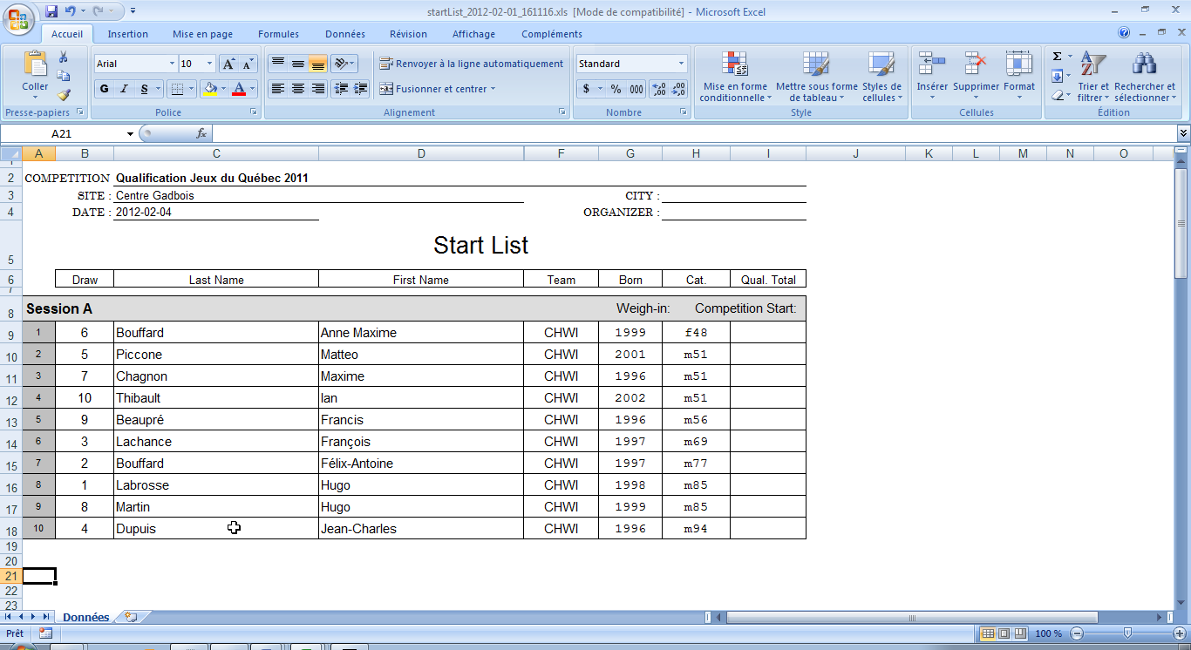
  3. Likewise, the “Cards” feature will produce the lifter cards. Note that you will get a security warning about the content. Please allow the macros to run in order to get proper page breaks.  
     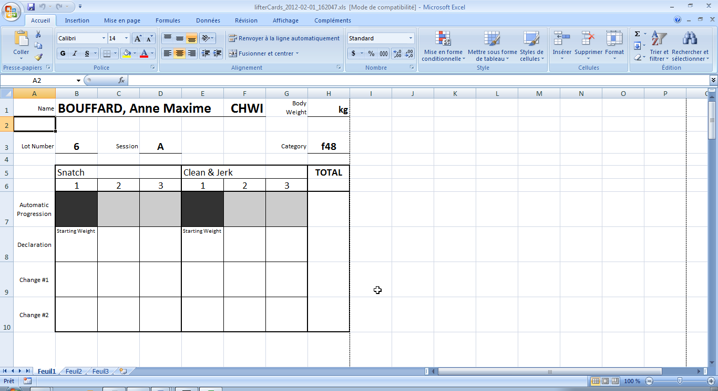

# Enter Assigned Referees for Each Session

If the referees are assigned ahead of time, you may enter them for each competition session.

* Go to the “Administration” – “Sessions” screen and use the “Edit” button.
* For each session, use the “Edit” button on each row to get the Session editing screen  
  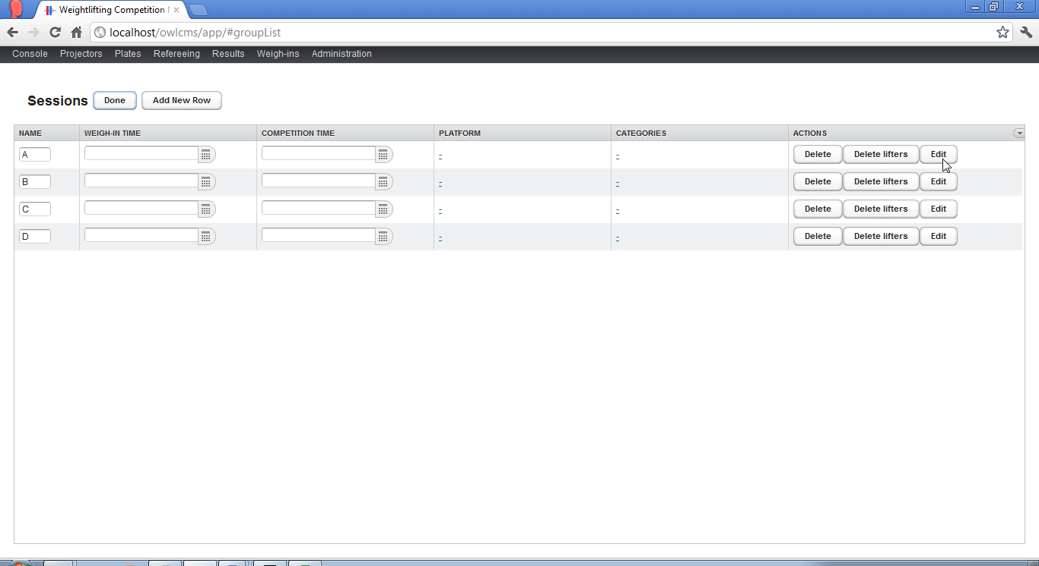
* You will then get a screen where the officials can be defined  
  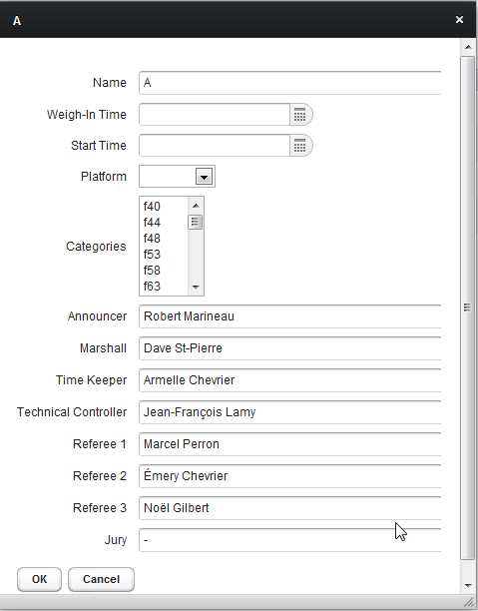
* This information can also be accessed and edited while the competition is in progress by going to the “Results” screen and selecting the session in the dropdown.

# Category Changes, Group Changes and Withdrawals.

* If a user changes categories, and the competition rules allow him to, you may if you wish change the registration category as explained in section 6. This is actually optional, because the program will compute the effective category based on the actual body weight recorded.
* If a user changes groups, typically because he did not meet the weight requirement, then should change the group, as explained in section 6. If this takes place after the announcer has already loaded the group, then the announcer should use the “Reload” button on his screen.
* If a lifter withdraws and has never been weighed, there is no need to do anything. Lifters that were not weighed do not appear in the results. You may of course, if you prefer, use the “Delete” button from the “Registrations” or “Weigh-in” pages to make sure they are gone.

# Weigh-ins

* The Weigh-in screen is reached from the Menu bar.
* It is identical in operations to the Registrations screen.
* Weigh-ins are normally done one session at a time; there is a drop-down at the top of the page to select which session is being weighed.

# Results

* The results screen presents the ranking. In order to update it, you must explicitly use the “Refresh” button.
* At the end of each session, you can produce a Result Sheet spreadsheet, by selecting the current session in the drop down.
* At the end of the competition, you can produce a results spreadsheet for the whole meet, by selecting the “blank” session (i.e., no session) and using the “Result Sheet” button.
* At the end of the competition, you may also produce a Competition Book by using the “Rankings and Points” button.

# Masters

The system is capable of handling Masters championships. This is enabled on the Competition editing page. However, these features are used less frequently, and tested less strenuously. If you intend to run a Masters championship with the program, kindly let the author know so a spot check can be done.